Github Link: https://github.com/yasaswini8777/neural-network--2

1. Write a program that takes two strings from the user: first_name, last_name. Pass these variables to full name function that should return the (full name). o For example: First_name = “your first name”, last_name = “your last name” ▪ Full_name = “your full name”

**Spring 2024: CS5720**

**Neural Networks and Deep Learning - ICP-2**

**Yasaswini Majety(700747747)**

**Solution:**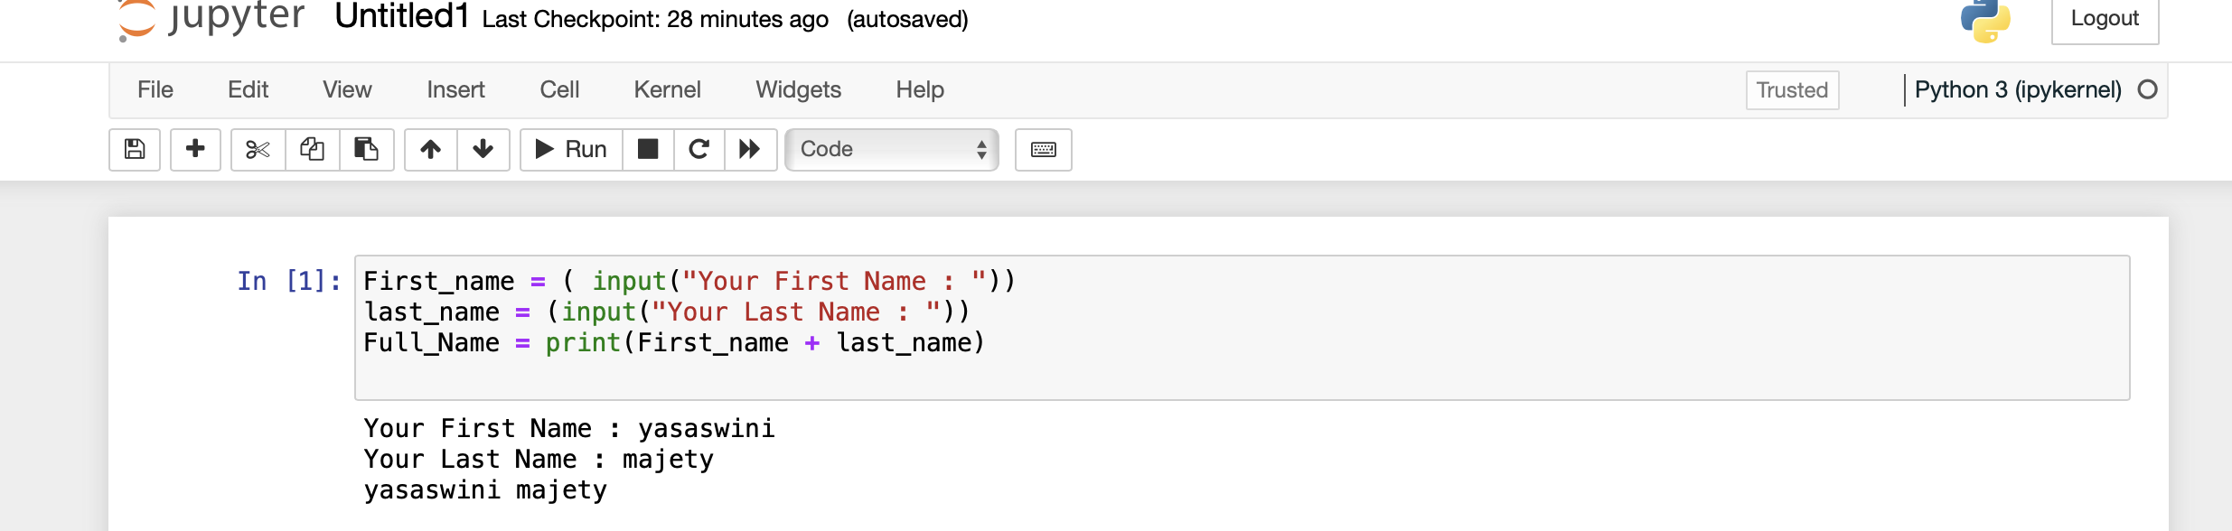

* Write function named “string_alternative” that returns every other char in the full_name string. Str=“Good evening”

Note: You need to create a function named “string_alternative” for this program and call it from main function.

**Solution:**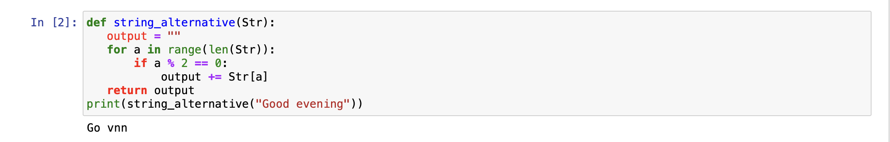

2. Write a python program to find the wordcount in a file (input.txt) for each line and then print the output.

o Finally store the output in output.txt file.

Example:

Input: a file includes two lines:

Python Course

Deep Learning Course

Output:

Python Course

Deep Learning Course

Word_Count:

Python: 1

Course: 2

Deep: 1

Learning: 1

**Solution:**

3. Write a program, which reads heights (inches.) of customers into a list and convert these hei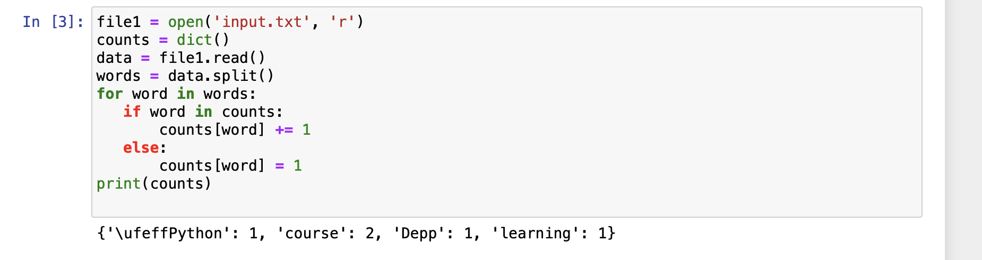ghts to centimeters in a separate list using:

1) Nested Interactive loop.

**Solution:**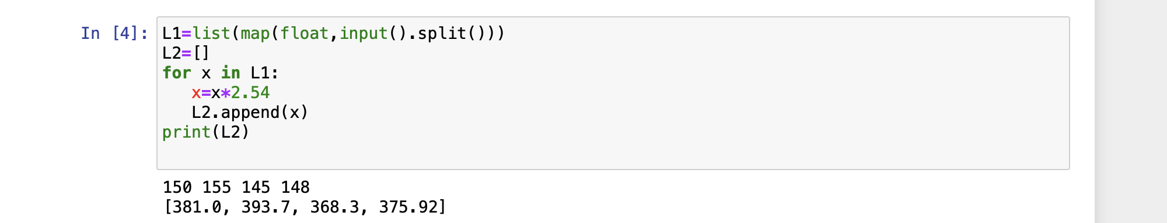

2) List comprehensions

**Solution:**